SA consumers urged to avoid excessive debt

The abuse of credit is one of the key reasons why millions of South African households are in financial difficulty, according to Marc Sternberg, managing director of Spark ATM Systems.
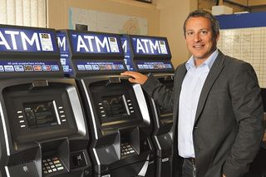
Image: Financial Mail
Managing director of Spark ATM Systems, Marc Sternberg

More risk from SA's new debtors
A recent financial wellness study by the University of SA and Momentum showed that nearly 60% of 3,000 South African households sampled were shown to be in bad debt.
Sternberg said that the ease with which South African households could access credit in the form of personal loans and credit cards was resulting in many people spending beyond their means.
The study found that 4.8% of South African households were in dire debt from which they could not escape and 48.5% were in debt but still had a chance to recover.
"This access to credit is being fuelled by both retailers and banks, which, despite high debt levels amongst consumers, are increasingly eager to grant credit facilities through credit cards and personal loans," Sternberg said.
Standard & Poor's recently warned that rapid growth in unsecured lending was starting to create a credit bubble following a 35% year-on-year increase in unsecured lending to households for February.
Sternberg said that consumers who relied on credit often failed to take into account the interest they were charged should they be unable to make their payments within the required time period.
"These interest rates can be as much as 20% per month and only further deepen the financial strain on already overly indebted consumers."
He added that paying for purchases on credit could sometimes result in consumers spending more money than they had intended.
"With credit cards in particular, it is extremely easy to get carried away, especially as people don't check their credit balances every day.
"It is only at the end of the month that they realise they have overspent and cannot afford to service this debt," he said.
A better alternative, Sternberg said, was the use of cash or a debit card and spending only the money that one had in the bank. Even though it could be extremely difficult and required proper budgeting and planning skills, this would ensure that consumers stayed out of the "dreaded" financial debt trap

